Department of CSE



**Project Name: Banking Management System**

**Course Code: CSE-3116**

Supervised By

Md.Hadifur Rahman

Assistant Professor

Dept. of CSE,MBSTU

Submitted By

Md.Misbahur Rahman

CE-13021

**Session: 2012-2013**

3rd year 1st semester

**Introduction:**

My project is Banking Management System. It will be beneficial for customers and bankers to use and access their bank account easily. This banking system provides the access to the employee to create account for staff or customer and the staff or customer can withdraw or deposit the cash from their own account.

**Features :**

In my banking system a customer can submit his/her deposit amount if he/she has an account or can withdraw the cash or can create a new account in this bank. Customer can view his/her bank account balance. One can easily access all this things by login through his unique account number.

**Software Requirements:**

* NetBeans
* Oracle 10g

**The following documentation provides my Banking System:**

1.Login Form.

2.Main Interface.

3.Registration Interface.

* Staff Registration.
* Customer registration.

3.Deposit Form

5.Withdraw Form.

6.Login Interface.

7.Customer Details.

8.Deposit Details.

9.Withdraw Details.

**Analysis of the development interface:**

**1.LoginForm:**First interface is login interface. When a person want to enter into this banking application, then he/she will need to know the user name and password, otherwise he/she can not access this banking application.

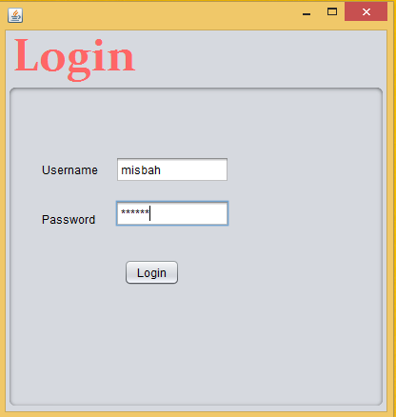

It is the first security for a this application.Because anyone can not access this banking application without knowing this security.

**//This code for Database connection**

package com**;//My project is created within a package com**

importjava.sql.Connection;**//.connection and .DriverManager is use for set up a connection to a //database**

importjava.sql.DriverManager;

importjava.sql.ResultSet;**//.ResultSet is use  for returns all the records from database**

importjava.sql.Statement;**//to execute a SQL statement on table from database**

importjavax.swing.JOptionPane;**//for accepting user input, and displaying results**

public class JavaConnectDb{ public static Connection ConnecrDb()

{ try

{ Class.forName("oracle.jdbc.OracleDriver");

**//By this I connect java to database where database username ‘’misbah’’ and password ‘’system’’**

Connection con=DriverManager.getConnection("jdbc:oracle:thin:@ MISBAH.mshome.net:1521:oracl","misbah","system");

return con;

}catch(Exception e){

JOptionPane.showMessageDialog(null, e);

}

return null }

}

**//LoginForm code**

package com;

importjava.awt.Toolkit;**//In Toolkit field math,image,all java API are work**

importjava.awt.event.WindowEvent;**//it  represents the change in state of a window**

importjava.sql.Connection;

importjava.sql.DriverManager;

importjava.sql.ResultSet;

importjava.sql.SQLException;

importjava.sql.Statement;

importjavax.swing.JOptionPane;

**// To write changes to the database, such as for INSERT or UPDATE operations, we use // PreparedStatement**

importoracle.jdbc.OraclePreparedStatement;

importoracle.jdbc.OracleResultSet**; //for returns all the records from database**

importjava.awt.event.*;

public class Login extends javax.swing.JFrame {

Connection conn = null;

OraclePreparedStatementpst = null;

OracleResultSetrs = null;

public Login() {

initComponents();

setLocationRelativeTo(null);

} private void jButton1ActionPerformed(java.awt.event.ActionEventevt) {

// TODO add your handling code here:

conn=JavaConnectDb.ConnecrDb();

try { String sq1 = "select *from login where user_id=? and password=?";

**//when we give input then it check from database that this user_id and password is correct or incorrect**

pst = (OraclePreparedStatement) conn.prepareStatement(sq1);

pst.setString(1, username.getText());

pst.setString(2, password.getText());

rs = (OracleResultSet) pst.executeQuery();

if (rs.next()) {

JOptionPane.showMessageDialog(null, "The username and password is successfully verified");

this.dispose();

Main_Interface n=new Main_Interface();

n.setVisible(true);

} else {

JOptionPane.showMessageDialog(null, "Misbah") }

} catch (Exception e) {

JOptionPane.showMessageDialog(null, e);

} }

public static void main(String args[]){

java.awt.EventQueue.invokeLater(new Runnable() {

public void run() {

new Login().setVisible(true);

}

});

}

// Variables declaration - do not modify

privatejavax.swing.JButton jButton1**; //Here show which variables I used**

privatejavax.swing.JLabel jLabel1;

privatejavax.swing.JLabel jLabel2;

privatejavax.swing.JPanel jPanel1;

privatejavax.swing.JPasswordField password;

privatejavax.swing.JTextField username;

// End of variables declaration

}

**After successfully verified this message show**

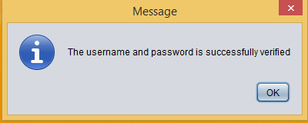

**2.Main Interface:** After access successfully the login form, the user face the main interface.

Main interface contain all of other interfaces. He/She can access all of other interface from the main interface.

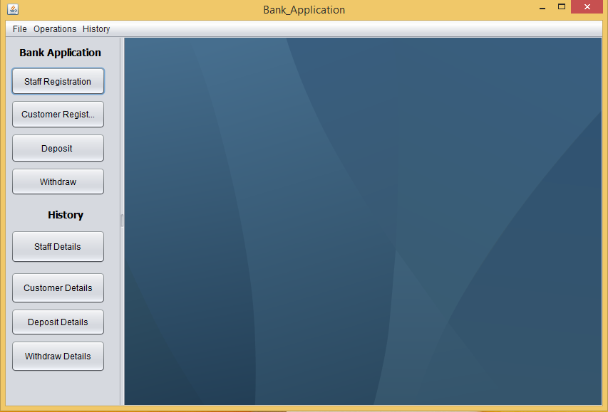

**3.Registration Interface:**In registration interface an employee can register staffs or customers, because there are two types of registration interface**.**

**a.** Staff Registration interface.

**b.** Customer Registration interface.

**Staff Transaction Module:**

Features includes:

* Creation of new banking Staff
* Employee Rank as Director,GeneralManager,Assistant general Manager.
* Each Employee login identified by his/her id number.
* Existing staff details

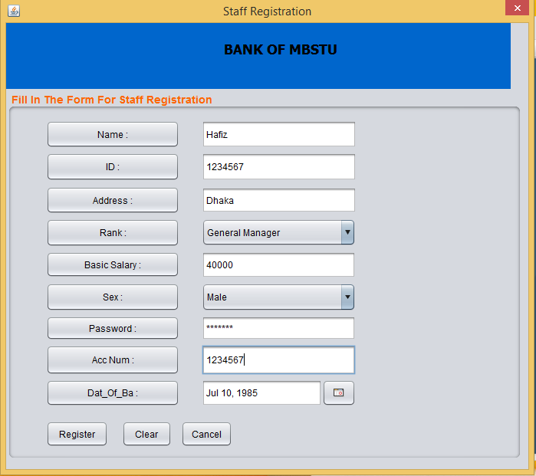

If staff registration is successfully completed then this message will show

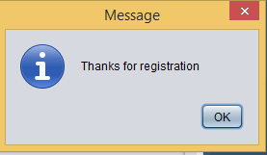

**//Code for staff registration**

package com;

importjava.io.FileInputStream;//**bytes stream class that’s used to read bytes from file**

importjava.sql.Connection;

importjava.sql.DriverManager;

importjava.sql.ResultSet;

importjava.sql.Statement;

importjava.util.ArrayList;**//it is adynamic data structure, it can be added and removed from the list**

importjavax.swing.JOptionPane;

importjavax.swing.table.DefaultTableModel;//**makes it easy to assign column identifiers**

importoracle.jdbc.OraclePreparedStatement;

importoracle.jdbc.OracleResultSet;

public class Staff_Registration extends javax.swing.JDialog {

Connection conn = null;

OraclePreparedStatementpst = null;

OracleResultSetrs = null;

publicStaff_Registration(java.awt.Frame parent, boolean modal) {

super(parent, modal);

initComponents();

setLocationRelativeTo(null);

}

public Connection getConnection() {

Connection con;

try {con = DriverManager.getConnection("jdbc:oracle:thin:@ MISBAH.mshome.net:1521:oracl","misbah","system");

return con;

} catch (Exception e) {

e.printStackTrace();

return null;

} }

private void jButton8ActionPerformed(java.awt.event.ActionEventevt) {

try{conn=JavaConnectDb.ConnecrDb()

Class.forName("oracle.jdbc.OracleDriver");

Connection con=DriverManager.getConnection("jdbc:oracle:thin:@ MISBAH.mshome.net:1521:oracl","misbah","system");

String sq1 = "insert into st_reg(name,id,address,rank,basc_salary,sex,password,acc_num,dob) values(?,?,?,?,?,?,?,?,?)";

pst = (OraclePreparedStatement) conn.prepareStatement(sq1);

pst.setString(1,jTextField1.getText());

pst.setString(2,jTextField4.getText());

pst.setString(3,jTextField2.getText());

pst.setString(4,jComboBox1.getSelectedItem().toString());

pst.setString(5,jTextField3.getText());

pst.setString(6,jComboBox5.getSelectedItem().toString());

pst.setString(7,jPasswordField1.getText());

pst.setString(8,jTextField5.getText());

pst.setTimestamp(9, new java.sql.Timestamp(jDateChooser2.getDate().getTime()) );

int status=pst.executeUpdate();

if(status>0)

{

JOptionPane.showMessageDialog(null, "Thanks for registration");

}

else

JOptionPane.showMessageDialog(null, "The username and password is successfully verified");

}catch(Exception e){System.out.println(e);}

}

private void jButton10ActionPerformed(java.awt.event.ActionEventevt) {

this.dispose();

}

public static void main(String args[]) {

java.awt.EventQueue.invokeLater(new Runnable() {

public void run() {

Staff_Registration dialog = new Staff_Registration(new javax.swing.JFrame(), true);

dialog.addWindowListener(new java.awt.event.WindowAdapter() {

@Override

public void windowClosing(java.awt.event.WindowEvent e) {

System.exit(0);

} });

dialog.setVisible(true);

}});}

// Variables declaration - do not modify

privatejavax.swing.ButtonGroup buttonGroup1;

privatejavax.swing.JButton jButton1;

privatejavax.swing.JButton jButton10;

privatejavax.swing.JButton jButton11;

privatejavax.swing.JButton jButton12;

privatejavax.swing.JButton jButton2;

privatejavax.swing.JButton jButton3;

privatejavax.swing.JButton jButton4;

privatejavax.swing.JButton jButton5;

privatejavax.swing.JButton jButton6;

privatejavax.swing.JButton jButton7;

privatejavax.swing.JButton jButton8;

privatejavax.swing.JButton jButton9;

privatejavax.swing.JComboBox jComboBox1;

privatejavax.swing.JComboBox jComboBox5;

privatecom.toedter.calendar.JDateChooser jDateChooser2;

privatejavax.swing.JLabel jLabel1;

privatejavax.swing.JPanel jPanel1;

privatejavax.swing.JPanel jPanel2;

privatejavax.swing.JPanel jPanel3;

privatejavax.swing.JPanel jPanel4;

privatejavax.swing.JPasswordField jPasswordField1;

privatejavax.swing.JTextField jTextField1;

privatejavax.swing.JTextField jTextField2;

privatejavax.swing.JTextField jTextField3;

privatejavax.swing.JTextField jTextField4;

privatejavax.swing.JTextField jTextField5;

// End of variables declaration

}

**Customer Transaction Module:**

Features includes:

* Creation of new banking customer
* Account type – Current Account, Savings Account.
* Customer Creation Form.
* Existing customer details
* Each customer login identified by Account No.

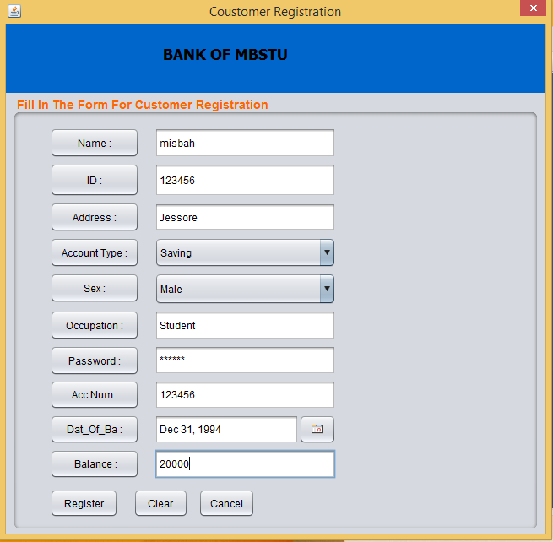

If staff registration is successfully completed then this message will show



**//Code for customer registration**

package com;

importjava.sql.Connection;

importjava.sql.DriverManager;

importjavax.swing.JOptionPane;

importoracle.jdbc.OraclePreparedStatement;

importoracle.jdbc.OracleResultSet;

public class Customer_Registration extends javax.swing.JDialog {

Connection conn = null;

OraclePreparedStatementpst = null;

OracleResultSetrs = null;

publicCustomer_Registration(java.awt.Frame parent, boolean modal) {

super(parent, modal);

initComponents();

setLocationRelativeTo(null);

}

public Connection getConnection() {

Connection con;

try{con = DriverManager.getConnection("jdbc:oracle:thin:@ MISBAH.mshome.net:1521:oracl", "misbah", "system");

return con;

} catch (Exception e) e.printStackTrace();

return null;

}}

private void jButton8ActionPerformed(java.awt.event.ActionEventevt) {

try{ conn = JavaConnectDb.ConnecrDb();

Class.forName("oracle.jdbc.OracleDriver");

Connection con = DriverManager.getConnection("jdbc:oracle:thin:@ MISBAH.mshome.net:1521:oracl", "misbah", "system");

String sq1 = "insert into ct_reg(name,id,address,acc_type,sex,occupation,password,acc_num,dob,init_balan) values(?,?,?,?,?,?,?,?,?,?)";

pst = (OraclePreparedStatement) conn.prepareStatement(sq1);

pst.setString(1, jTextField1.getText());

pst.setString(2, jTextField5.getText());

pst.setString(3, jTextField2.getText());

pst.setString(4, jComboBox1.getSelectedItem().toString());

pst.setString(5, jComboBox2.getSelectedItem().toString());

pst.setString(6, jTextField3.getText());

pst.setString(7, jPasswordField1.getText());

pst.setString(8, jTextField6.getText());

pst.setTimestamp(9, new java.sql.Timestamp(jDateChooser1.getDate().getTime()));

pst.setString(10, jTextField4.getText());

int status = pst.executeUpdate();

if (status > 0) {

JOptionPane.showMessageDialog(null, "Thanks for registration");

} else {

JOptionPane.showMessageDialog(null, "The username and password is successfully verified");

} } catch (Exception e) {

System.out.println(e);

} }

private void jButton10ActionPerformed(java.awt.event.ActionEventevt) {

this.dispose(); }

public static void main(String args[]) {

java.awt.EventQueue.invokeLater(new Runnable() {

public void run() {

Customer_Registration dialog = new Customer_Registration(new javax.swing.JFrame(), true);

dialog.addWindowListener(new java.awt.event.WindowAdapter() {

@Override

public void windowClosing(java.awt.event.WindowEvent e) {

System.exit(0);

} });

dialog.setVisible(true);

} }); }

// Variables declaration - do not modify

privatejavax.swing.JButton jButton1;

privatejavax.swing.JButton jButton10;

privatejavax.swing.JButton jButton11;

privatejavax.swing.JButton jButton12;

privatejavax.swing.JButton jButton13;

privatejavax.swing.JButton jButton2;

privatejavax.swing.JButton jButton3;

privatejavax.swing.JButton jButton4;

privatejavax.swing.JButton jButton5;

privatejavax.swing.JButton jButton6;

privatejavax.swing.JButton jButton7;

privatejavax.swing.JButton jButton8;

privatejavax.swing.JButton jButton9;

privatejavax.swing.JComboBox jComboBox1;

privatejavax.swing.JComboBox jComboBox2;

privatecom.toedter.calendar.JDateChooser jDateChooser1;

privatejavax.swing.JLabel jLabel1;

privatejavax.swing.JPanel jPanel1;

privatejavax.swing.JPanel jPanel2;

privatejavax.swing.JPasswordField jPasswordField1;

privatejavax.swing.JTextField jTextField1;

privatejavax.swing.JTextField jTextField2;

privatejavax.swing.JTextField jTextField3;

privatejavax.swing.JTextField jTextField4;

privatejavax.swing.JTextField jTextField5;

privatejavax.swing.JTextField jTextField6;

// End of variables declaration

}

**6.Staff Details:**  In staff details table one can see the information of registered staff/employee.

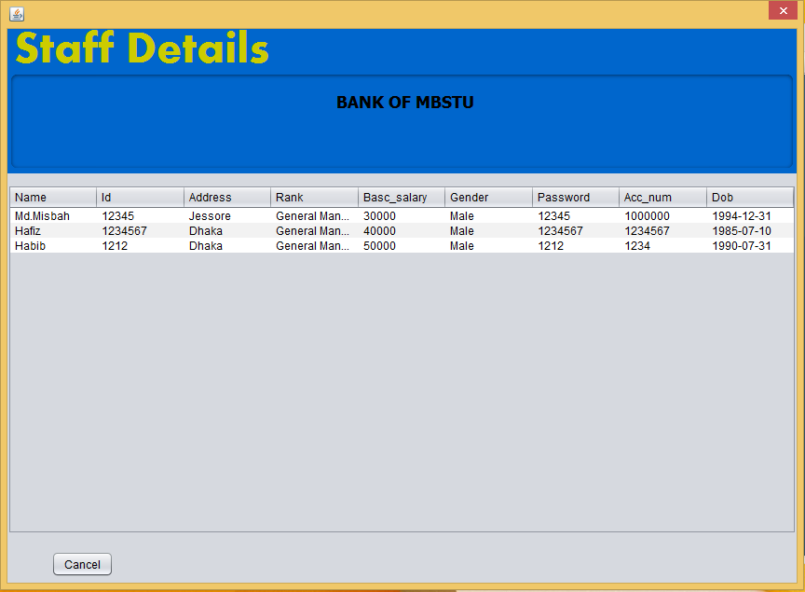

**//Code for Staff details**

package com;

importjava.sql.Connection;

importjava.sql.DriverManager;

importjava.sql.ResultSet;

importjava.sql.Statement;

importjava.util.ArrayList;

importjavax.swing.JOptionPane;

importjavax.swing.table.DefaultTableModel;

importoracle.jdbc.OraclePreparedStatement;

importoracle.jdbc.OracleResultSet;

public class Staff_reg_table extends javax.swing.JDialog {

Connection conn;

OraclePreparedStatementpst;

OracleResultSetrs;

public Connection getConnection() {

Connection con;

conn = JavaConnectDb.ConnecrDb();

try {

con = DriverManager.getConnection("jdbc:oracle:thin:@ MISBAH.mshome.net:1521:oracl", "misbah", "system");

return con;

} catch (Exception e) {

e.printStackTrace();

return null;

} }

publicArrayList<staff_class>getUserList() {

ArrayList<staff_class>usersList= new ArrayList<staff_class>();

Connection connection = getConnection();

conn = JavaConnectDb.ConnecrDb();

String query = "select * from st_reg";

Statement st;

ResultSetrs;

try {

String driverName = "oracle.jdbc.driver.OracleDriver";

Class.forName(driverName);

st = connection.createStatement();

rs = st.executeQuery(query);

staff_class user;

while (rs.next()) {

user = new staff_class(rs.getString("name"), rs.getString("id"), rs.getString("address"), rs.getString("rank"), rs.getInt("basc_salary"), rs.getString("sex"), rs.getString("password"), rs.getString("acc_num"), rs.getDate("dob"));

usersList.add(user);

}

} catch (Exception e) {

e.printStackTrace();

}

returnusersList;

}

public void staff_reg_table() {

ArrayList<staff_class> list = getUserList();

DefaultTableModel model;

model = (DefaultTableModel) jTable_staff_reg_table.getModel();

Object[] row;

row = new Object[10];

for (int i = 0; i <list.size(); i++) {

row[0] = list.get(i).getname();

row[1] = list.get(i).getId();

row[2] = list.get(i).getaddress();

row[3] = list.get(i).getrank();

row[4] = list.get(i).getbasc_salary();

row[5] = list.get(i).getsex();

row[6] = list.get(i).getpassword();

row[7] = list.get(i).getacc_num();

row[8] = list.get(i).getdob();

model.addRow(row);

} }

public void executeSQLQuery(String query, String messege) {

Connection con = getConnection();

Statement st;

try {

st = con.createStatement();

if ((st.executeUpdate(query)) == 1) {

//refresh jtable data

DefaultTableModel model;

model = (DefaultTableModel) jTable_staff_reg_table.getModel();

model.setRowCount(0);

staff_reg_table();

JOptionPane.showMessageDialog(null, "Data " + messege + "succesfully");

} else {

JOptionPane.showMessageDialog(null, "Data Not " + messege);

}

} catch (Exception ex) {

ex.printStackTrace();

} }

publicStaff_reg_table(java.awt.Frame parent, boolean modal) {

super(parent, modal);

initComponents();

staff_reg_table();

}

public static void main(String args[]) {

/* Create and display the dialog */

java.awt.EventQueue.invokeLater(new Runnable() {

public void run() {

Staff_reg_table dialog = new Staff_reg_table(new javax.swing.JFrame(), true);

dialog.addWindowListener(new java.awt.event.WindowAdapter() {

@Override

public void windowClosing(java.awt.event.WindowEvent e) {

System.exit(0);} });

dialog.setVisible(true);

} }); }

// Variables declaration - do not modify

privatejavax.swing.JLabel jLabel1;

privatejavax.swing.JPanel jPanel3;

privatejavax.swing.JScrollPane jScrollPane1;

privatejavax.swing.JTablejTable_staff_reg_table;

// End of variables declaration

}

**6.Customer Details:** In customer details table one can see the information of registered customer.

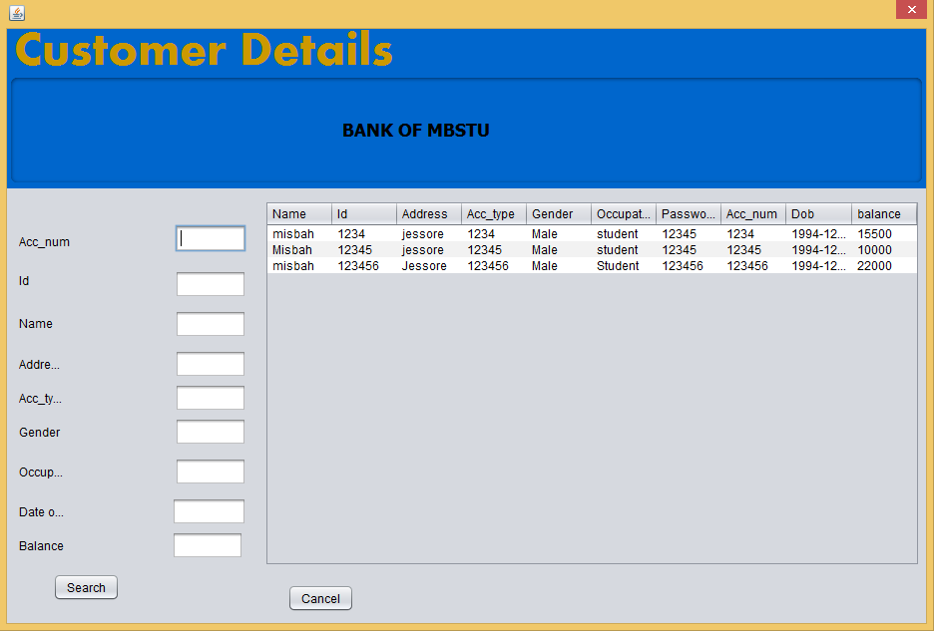

**An employee can search a customer by his/her acc_num**

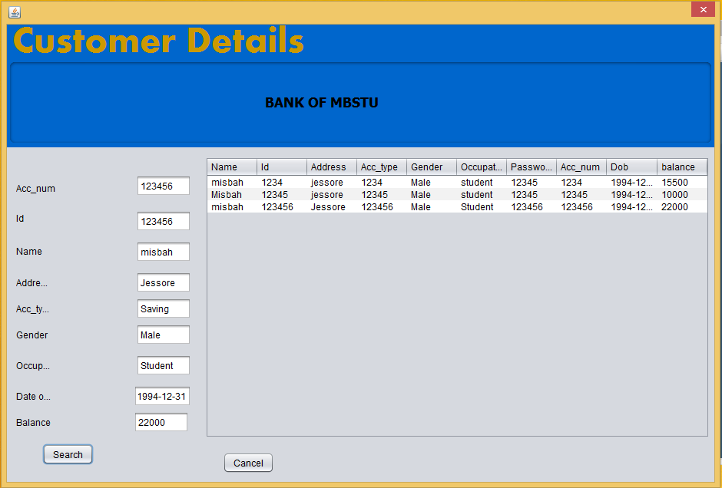

**If the account number is wrong then this message will show**

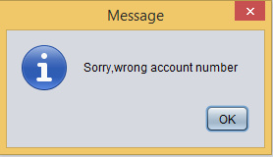

**//Code for customer details**

package com;

import java.sql.Connection;

import java.sql.Date;

import java.sql.DriverManager;

import java.sql.ResultSet;

import java.sql.Statement;

import java.util.ArrayList;

import javax.swing.JOptionPane;

import javax.swing.table.DefaultTableModel;

import oracle.jdbc.OraclePreparedStatement;

import oracle.jdbc.OracleResultSet;

public class Cust_reg_teble extends javax.swing.JDialog {

public Cust_reg_teble(java.awt.Frame parent, boolean modal) {

super(parent, modal);

initComponents();

setLocationRelativeTo(null);

staff_reg_table();

}

Connection conn;

OraclePreparedStatement pst;

OracleResultSet rs;

public Connection getConnection() {

Connection con;

conn = JavaConnectDb.ConnecrDb();

try {

con = DriverManager.getConnection("jdbc:oracle:thin:@MISBAH:1521:orcl", "misbah", "system");

return con;

} catch (Exception e) {

e.printStackTrace();

return null;

} }

public ArrayList<Custom_class> getUserList() {

ArrayList<Custom_class> usersList = new ArrayList<Custom_class>();

Connection connection = getConnection();

conn = JavaConnectDb.ConnecrDb();

String query = "select * from ct_reg";

Statement st;

ResultSet rs;

try {

String driverName = "oracle.jdbc.driver.OracleDriver";

Class.forName(driverName);

st = connection.createStatement();

rs = st.executeQuery(query);

Custom_class user;

while (rs.next()) {

user = new Custom_class(rs.getString("name"), rs.getString("id"), rs.getString("address"), rs.getString("acc_type"), rs.getString("sex"), rs.getString("occupation"), rs.getString("password"), rs.getString("acc_num"), rs.getDate("dob"), rs.getInt("balance"));

usersList.add(user);

} } catch (Exception e) {

e.printStackTrace(); }

return usersList; }

public void staff_reg_table() {

ArrayList<Custom_class> list = getUserList();

DefaultTableModel model;

model = (DefaultTableModel) jTable1.getModel();

Object[] row;

row = new Object[10];

for (int i = 0; i < list.size(); i++) {

row[0] = list.get(i).getname();

row[1] = list.get(i).getId();

row[2] = list.get(i).getaddress();

row[3] = list.get(i).getacc_num();

row[4] = list.get(i).getsex();

row[5] = list.get(i).getoccupation();

row[6] = list.get(i).getpassword();

row[7] = list.get(i).getacc_num();

row[8] = list.get(i).getdob();

row[9] = list.get(i).get_balance();

model.addRow(row);

} }

public void executeSQLQuery(String query, String messege) {

Connection con = getConnection();

Statement st;

try {

st = con.createStatement();

if ((st.executeUpdate(query)) == 1) {

//refresh jtable data

DefaultTableModel model;

model = (DefaultTableModel) jTable1.getModel();

model.setRowCount(0);

staff_reg_table();

JOptionPane.showMessageDialog(null, "Data " + messege + "succesfully");

} else {

JOptionPane.showMessageDialog(null, "Data Not " + messege); }

} catch (Exception ex) {

ex.printStackTrace(); }

JOptionPane.showMessageDialog(null,"Sorry,There is no customer");

}catch(Exception e){ JOptionPane.showMessageDialog(null,e);}

}

private void jButton2ActionPerformed(java.awt.event.ActionEvent evt) {

// TODO add your handling code here:

this.dispose(); }

public static void main(String args[]) {

java.awt.EventQueue.invokeLater(new Runnable() {

public void run() {

Cust_reg_teble dialog = new Cust_reg_teble(new javax.swing.JFrame(), true);

dialog.addWindowListener(new java.awt.event.WindowAdapter() {

@Override

public void windowClosing(java.awt.event.WindowEvent e) {

System.exit(0);

} });

dialog.setVisible(true);

}}): }

// Variables declaration - do not modify

private javax.swing.JButton jButton1;

private javax.swing.JButton jButton2;

private javax.swing.JLabel jLabel1;

private javax.swing.JLabel jLabel10;

private javax.swing.JLabel jLabel11;

private javax.swing.JLabel jLabel12;

private javax.swing.JLabel jLabel2;

private javax.swing.JLabel jLabel3;

private javax.swing.JLabel jLabel4;

private javax.swing.JLabel jLabel6;

private javax.swing.JLabel jLabel7;

private javax.swing.JLabel jLabel8;

private javax.swing.JPanel jPanel1;

private javax.swing.JPanel jPanel3;

private javax.swing.JScrollPane jScrollPane2;

private javax.swing.JTable jTable1;

private javax.swing.JTextField jTextField1;

private javax.swing.JTextField jTextField10;

private javax.swing.JTextField jTextField2;

private javax.swing.JTextField jTextField3;

private javax.swing.JTextField jTextField4;

private javax.swing.JTextField jTextField5;

private javax.swing.JTextField jTextField6;

private javax.swing.JTextField jTextField8;

private javax.swing.JTextField jTextField9;

// End of variables declaration

} }

**4.Deposit Form**: In deposit form an employee can deposit customer’s balance. The amount of deposit will be recognized by a specific author, when he recognizes the amount he should put his own id which is unique. This unique id number will be stored in database. Thus, if any fault occurs he is liable for that fault. So it is completely safe for customers.

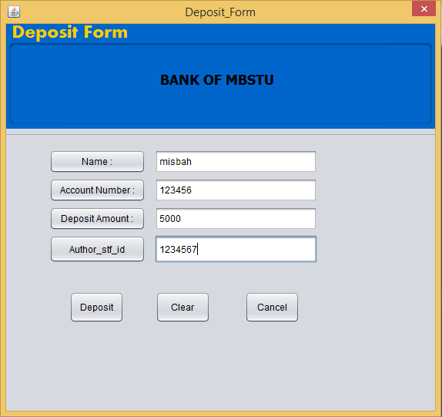

**After successfully deposit**

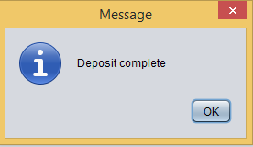

**5.Withdraw Form:**  In withdraw form an employee can withdraw customer’s balance. The amount of withdraw will be recognized by a specific author, when he recognizes the amount he should put his own id which is unique. This unique id number will be stored in database. Thus, if any fault occurs he is liable for that fault. So it is completely safe for customers.

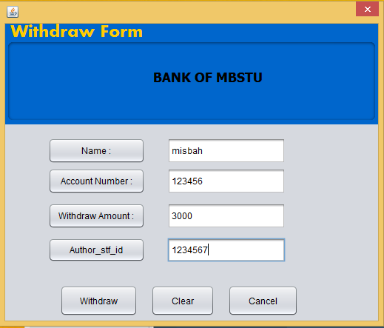

**After successfully withdraw money**

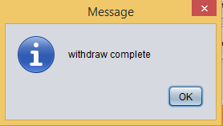

**7.DepositDetails:** In deposit details table one can see the deposit details of his/her account .

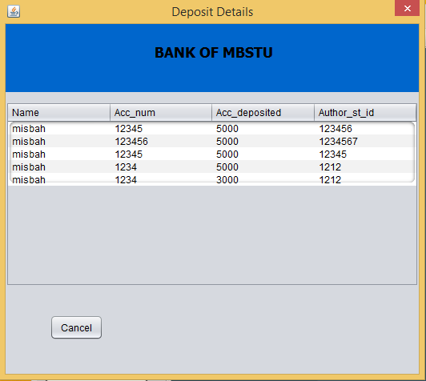

**8.WithdrawDetails:** In withdraw details table a person can see all withdraw information of his/her account .

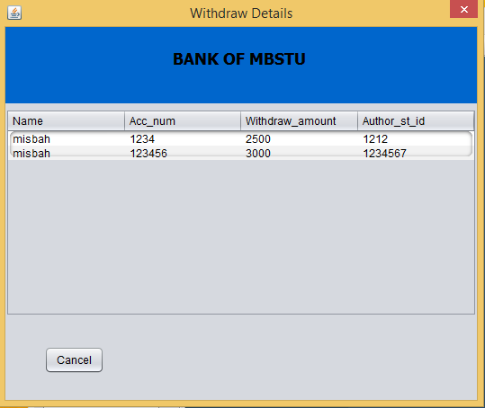

**Future Enhancements:**

For all the software applications there are always a scope of future enhancements. For this way there are lots of scope to improve the performance of my Banking System in the area of user interface, database performance, and query processing time , etc. So there are many things for future enhancement of this project. The future enhancements that are possible in the project are as follows.

* The future scopes for developing high security systems.
* Increased efficiency.
* Increased the facilities of customer services.
* Web Interface for online banking.
* In the area of data security and system security.
* Provide online tips and help.
* Improved management and accessibilities.